Quarterly Report – Public Page

Date of Report: 1st Quarterly Report – January 2, 2025
Contract Number: 693JK32410014POTA
Prepared for: DOT / PHMSA
Project Title: Use of Gamification and Generative AI to provide more effective training for hazardous condition and emergency response.
Prepared by: EnerSys Corporation
Contact Information: Russel W. Treat
E: rtreat@enersyscorp.com
O: 281-598-7110
For quarterly period ending: December 30, 2024

1: Items Completed During this Quarterly Period:

Item # | Task # | Activity/Deliverable | Title | Federal Cost | Cost Share
1 | 1 | Project Discussion with industrial partners and academia to seek additional input, develop TAP Team including Peer Review Members. | Project Plan and Research Scope | 2,832.00 | 4,000.00
4 | 13 | 1st Quarterly Status Report | Submit 1st Quarterly Report | 6,122.00 | 0.00

2: Items Not-Completed During this Quarterly Period:

Item # | Task # | Activity/Deliverable | Title | Federal Cost | Cost Share
2 | 2 | Conduct Kick Off Meeting, Revise Project Plan and Research Program. | Project Plan and Research Scope | 2,664.00 | 4,000.00
3 | 3 | Research, summarize and document current practice for performing Team Training. | Summary of current industry practice for conducting Emergency Response, Team Training, and Exercises. | 5,360.00 | 20,000.00

3: Project Financial Tracking During this Quarterly Period:

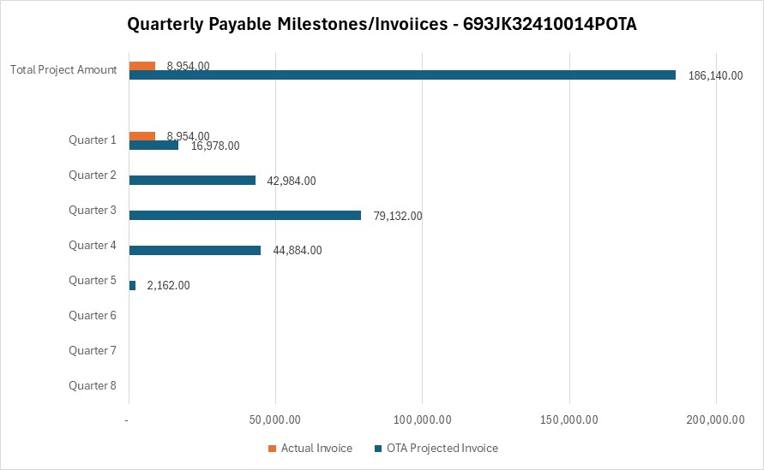

4: Project Technical Status –

Item # | Task # | Activity/Deliverable | Title
1 | 1 | Project Discussion with industrial partners and academia to seek additional input, develop TAP Team including Peer Review Members. | Project Plan and Research Scope
Multiple conversations were conducted with project participants to clarify objectives, scope, roles, and timelines. Specifically, a review of the project execution plan was conducted with ThreatGen principals to clarify the technology to be used in the project, and the approach to training the Generative AI. Conversations were conducted with the Mary K. O’Connor Process Safety Center to define a process whereby students at Texas A&M university can support research activities required by the project. Finally multiple conversation were conducted with both committed members of the TAP and potential members of the TAP to understand potential contribution, and to broaden participation.
4 | 13 | 1st Quarterly Status Report | Submit 1st Quarterly Report
Completed and submitted 1st Quarterly Report.

5: Project Schedule –

Item # | Task # | Activity/Deliverable | Title
2 | 2 | Conduct Kick Off Meeting, Revise Project Plan and Research Program. | Project Plan and Research Scope
Conflicts with end of year scheduling caused the Kick Off to be moved from the planned mid-December date to January 15.
3 | 3 | Research, summarize and document current practice for performing Team Training. | Summary of current industry practice for conducting Emergency Response, Team Training, and Exercises.
The initiation of the research tasks has been deferred until a relationship can be formalized with the Mary K O’Connor Process Safety Center. The center has expressed a commitment to participate, It is the intention to have this relationship in place prior to the January 15 Kick Off.

